Placing variables in their respective types

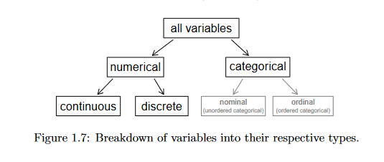

Definition of Numerical data

Numerical Discrete values

Discrete values/data: only take numerical values

Examples: the number of students in class, the results of rolling a 2-side dice can only have values between 2-12

Definition of Continuous Data: Continuous data can take any value with a range;

Examples: a Person height, this does not have fixed set of height, time of race

Categorical data: Categorical variables represent types of data which may be divided into groups. Examples of categorical variables are race, sex, age group, and educational level.

Ordinal Data: An ordinal variable is similar to a categorical variable.  The difference between the two is that there is a clear ordering of the variables.

Nominal is a variable that is categorical but has no clear ordering towards the variables.

When we suspect one variable might causally affect another, we label the first variable the explanatory variable and the second the response variable.

Explanatory -> might effect -> response variable

For many pairs of variables, there is no hypothesized relationship, and these labels would notbe applied to either variable in such cases